**Notifications Widget**

**Installation**

1. Distributed with the product, so no special installation requirements.

**How to use**

1. You will have to insert a new display Item of **Notifications Widget** type in the **Presentation Editor**
2. Within Widget Details tab you have to set up the widget settings .

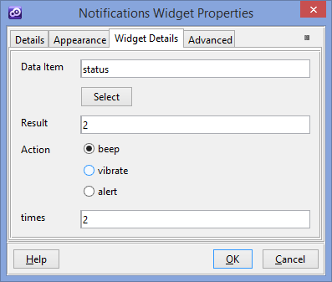

* **Data Item** - Date item which is used to evaluate when the notifications will be shown.
* **Result**  - The value which is used to establish when the condition is met. (   
  Date Item” field should be equal with “Result” to trigger the action.
* **Action** – Which kind of action ( alert/beep/vibrate) is triggered when the condition is met
* **Times** - The number of times to repeat the beep. This field is available only for “beep” action.
* **Time** – How long in milliseconds to vibrate the device, where 1000 milliseconds equals 1 second. This field is available only for “vibrate” action.
* **Message** – The message shown in the alert action**.** This field is available only for “alert” action.
* **Title** – The title of the alert **.** This field is available only for “alert” action.